Ellipse as a Locus

1. Definition
# Source: AI Source: Provided by: [Data Path: Persons Table -> ID Column: 1, Name_En Column: Motasem Essam] -> From: [ChatGPT] on [7/25/2026]
An ellipse is the locus of all points in a plane for which the sum of the distances to two fixed points is constant.
The two fixed points are called the foci.
If:
- $F_{1},F_{2}$= fixed foci
- $P$= variable point on the ellipse
- $2a$= fixed constant distance sum
then the defining condition is:
$$\boxed{PF_{1}+PF_{2}=2a}$$
Therefore:
$$\boxed{P\text{ lies on the ellipse }⟺ PF_{1}+PF_{2}=\text{constant}}$$
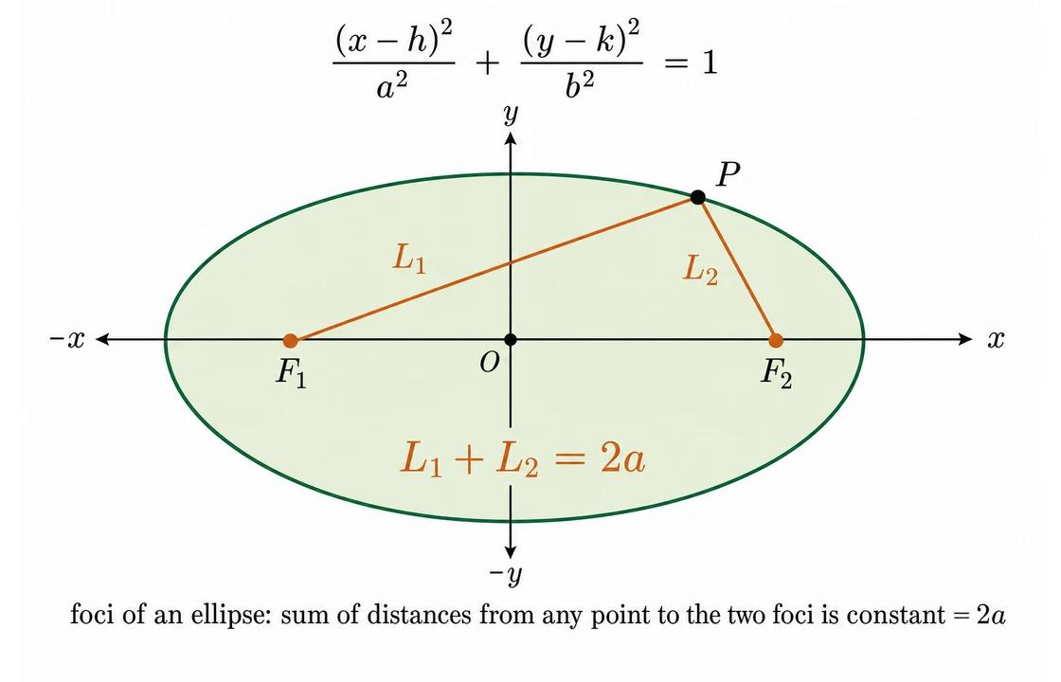
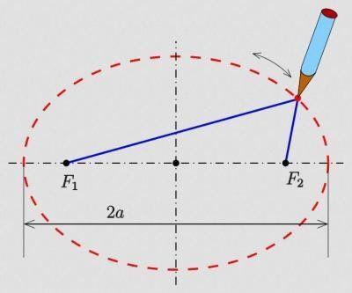
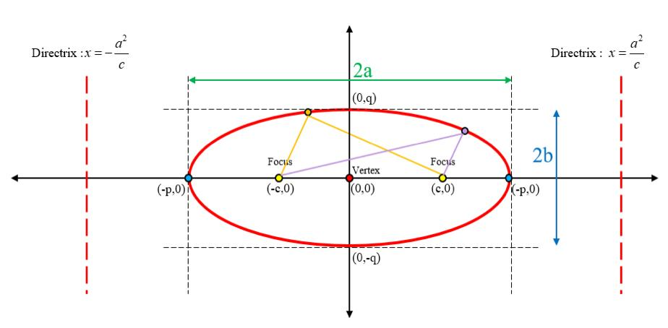
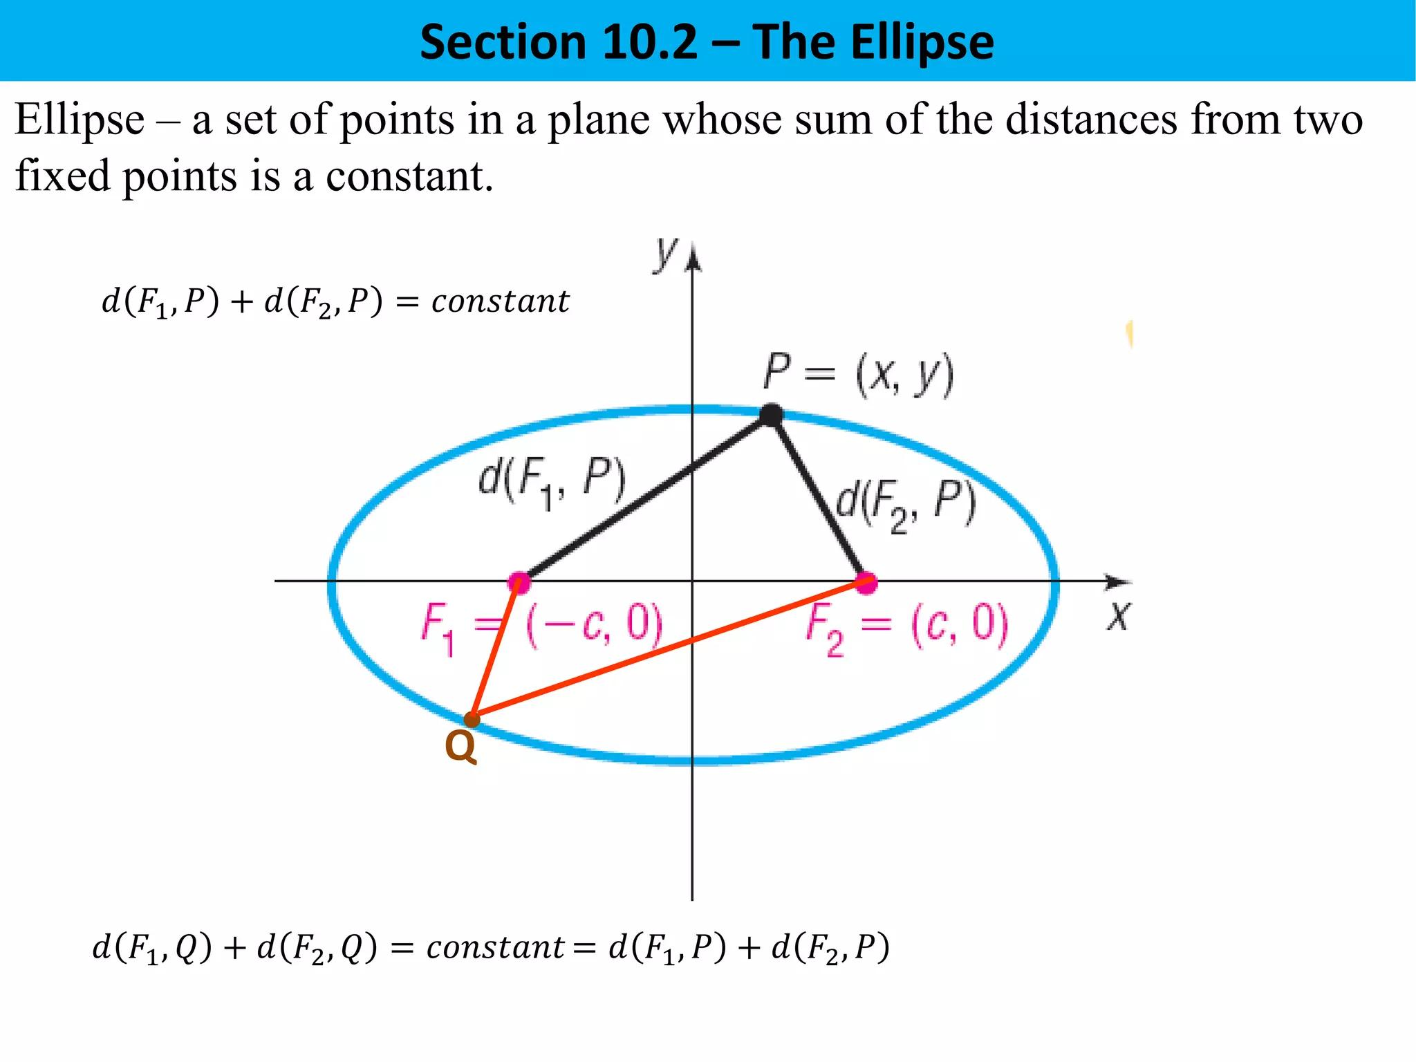
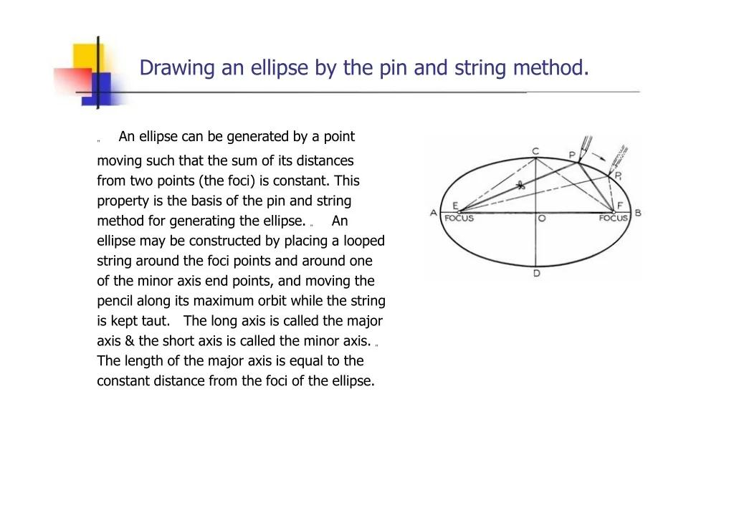

2. Simple Definition
# Source: AI Source: Provided by: [Data Path: Persons Table -> ID Column: 1, Name_En Column: Motasem Essam] -> From: [ChatGPT] on [7/25/2026]
An ellipse is the set of all points whose total distance from two fixed points is constant.
For every point $P$on the ellipse:
$$\boxed{PF_{1}+PF_{2}=2a}$$
The foci $F_{1}$and $F_{2}$remain fixed while $P$moves around the ellipse.

3. Fundamental Concept
# Source: AI Source: Provided by: [Data Path: Persons Table -> ID Column: 1, Name_En Column: Motasem Essam] -> From: [ChatGPT] on [7/25/2026]
An ellipse is determined by:
- Two fixed points $F_{1},F_{2}$, called the foci.
- A fixed positive constant $2a$, representing the sum of distances.
The locus condition is:
$$\boxed{PF_{1}+PF_{2}=2a}$$
Conceptually:
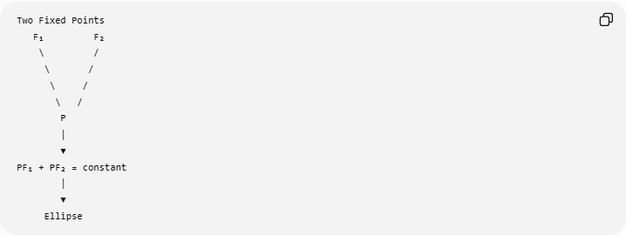
Two Fixed Points
F₁ F₂
\ /
\ /
\ /
\ /
P
│
▼
PF₁ + PF₂ = constant
│
▼
Ellipse
Every point satisfying this condition belongs to the ellipse.

4. The Two Foci
# Source: AI Source: Provided by: [Data Path: Persons Table -> ID Column: 1, Name_En Column: Motasem Essam] -> From: [ChatGPT] on [7/25/2026]
The fixed points are called the foci of the ellipse.
They are usually written:
$$\boxed{F_{1}, F_{2}}$$
and lie on the ellipse's major axis.
For a nondegenerate ellipse:
$$\boxed{F_{1}≠F_{2}}$$
and they are symmetric about the center.

5. Constant Sum of Distances
# Source: AI Source: Provided by: [Data Path: Persons Table -> ID Column: 1, Name_En Column: Motasem Essam] -> From: [ChatGPT] on [7/25/2026]
For every point $P$on the ellipse:
$$\boxed{PF_{1}+PF_{2}=2a}$$
where $a$is the semi-major axis.
For example, suppose:
$$PF_{1}=7$$
and
$$PF_{2}=5.$$
Then:
$$PF_{1}+PF_{2}=12.$$
If every point on the locus has this same sum, then:
$$\boxed{2a=12}$$
and therefore:
$$\boxed{a=6}.$$

6. Example 1 — Identifying an Ellipse Locus
# Source: AI Source: Provided by: [Data Path: Persons Table -> ID Column: 1, Name_En Column: Motasem Essam] -> From: [ChatGPT] on [7/25/2026]
Suppose two fixed points are:
$$F_{1}, F_{2}$$
and a moving point $P$must satisfy:
$$PF_{1}+PF_{2}=20.$$
Then the locus of $P$is an ellipse.
Since:
$$2a=20,$$
we have:
$$\boxed{a=10}.$$
Thus:
$$\boxed{PF_{1}+PF_{2}=20}$$
defines an ellipse with semi-major axis $10$.

7. Why the Locus Is an Ellipse
# Source: AI Source: Provided by: [Data Path: Persons Table -> ID Column: 1, Name_En Column: Motasem Essam] -> From: [ChatGPT] on [7/25/2026]
Suppose $P$moves while maintaining:
$$PF_{1}+PF_{2}=2a.$$
If $P$moves closer to $F_{1}$, then $PF_{1}$decreases.
To maintain the constant sum, $PF_{2}$must increase.
Similarly, if $P$moves closer to $F_{2}$, then $PF_{1}$increases.
The points satisfying this condition form a smooth closed curve:
$$\boxed{\text{Ellipse}}$$

8. Geometric Construction
# Source: AI Source: Provided by: [Data Path: Persons Table -> ID Column: 1, Name_En Column: Motasem Essam] -> From: [ChatGPT] on [7/25/2026]
An ellipse can be constructed using the two-focus string method.
Given two fixed foci $F_{1}$and $F_{2}$:
- Fix the two points $F_{1}$and $F_{2}$.
- Use a string whose total effective length is $2a$.
- Keep the string attached to the two foci.
- Pull the string tight with a pencil.
- Move the pencil while keeping the string taut.
- The pencil traces the ellipse.
At every position:
$$\boxed{PF_{1}+PF_{2}=2a}.$$
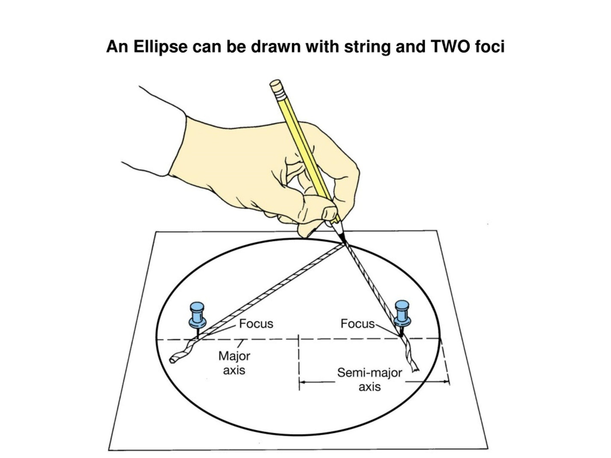
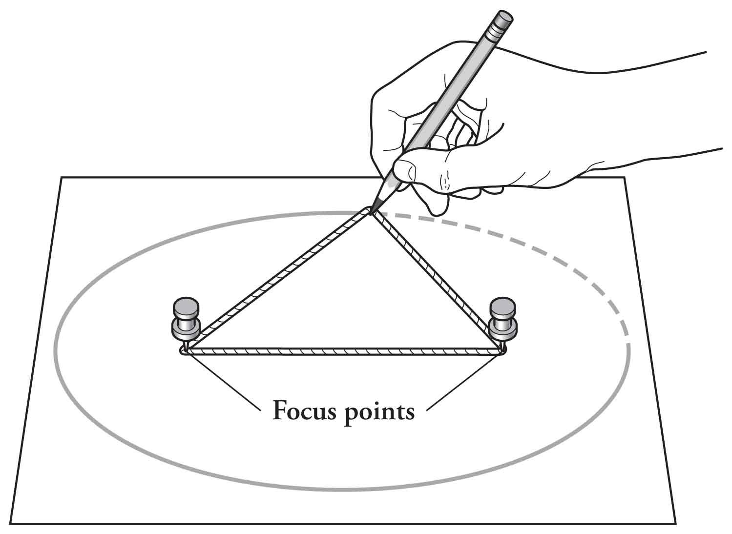
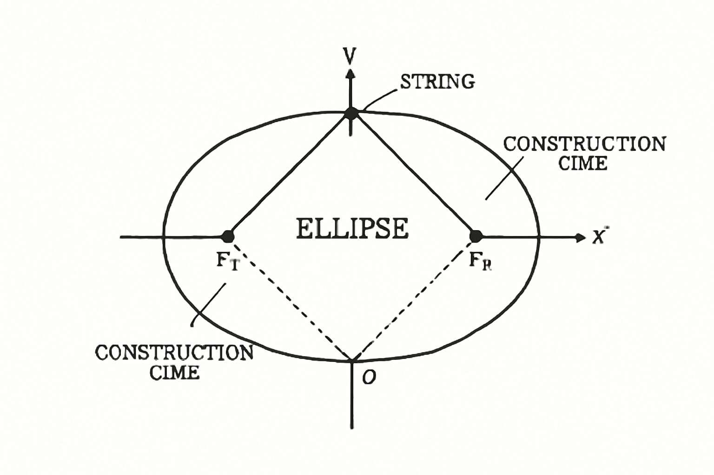
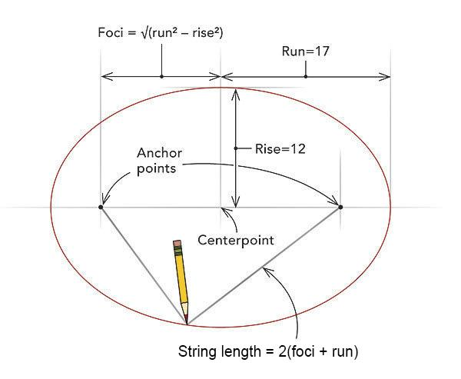

9. Center of an Ellipse
# Source: AI Source: Provided by: [Data Path: Persons Table -> ID Column: 1, Name_En Column: Motasem Essam] -> From: [ChatGPT] on [7/25/2026]
The center of an ellipse is the midpoint of the segment joining its foci.
If $O$is the center:
$$\boxed{OF_{1}=OF_{2}=c}$$
where $c$is the distance from the center to either focus.
The full distance between the foci is:
$$\boxed{F_{1}F_{2}=2c}.$$

10. Major Axis
# Source: AI Source: Provided by: [Data Path: Persons Table -> ID Column: 1, Name_En Column: Motasem Essam] -> From: [ChatGPT] on [7/25/2026]
The major axis is the longest diameter of the ellipse.
Its length is:
$$\boxed{2a}.$$
The semi-major axis is:
$$\boxed{a}.$$
The foci lie on the major axis.
For a horizontal ellipse:
$$F_{1}=\left(- , c0\right), F_{2}=\left(c , 0\right).$$
For a vertical ellipse:
$$F_{1}=\left(0 , -c\right), F_{2}=\left(0 , c\right).$$

11. Minor Axis
# Source: AI Source: Provided by: [Data Path: Persons Table -> ID Column: 1, Name_En Column: Motasem Essam] -> From: [ChatGPT] on [7/25/2026]
The minor axis is the shortest diameter of the ellipse.
Its length is:
$$\boxed{2b}.$$
The semi-minor axis is:
$$\boxed{b}.$$
For an ellipse:
$$\boxed{a≥b>0}.$$

12. Fundamental Relationship
# Source: AI Source: Provided by: [Data Path: Persons Table -> ID Column: 1, Name_En Column: Motasem Essam] -> From: [ChatGPT] on [7/25/2026]
For an ellipse:
$$\boxed{c^{2}=a^{2}-b^{2}}$$
or:
$$\boxed{b^{2}=a^{2}-c^{2}}.$$
Here:
- $a$= semi-major axis
- $b$= semi-minor axis
- $c$= center-to-focus distance
Therefore:
$$\boxed{F_{1}F_{2}=2c}.$$

13. Coordinate Equation — Horizontal Ellipse
# Source: AI Source: Provided by: [Data Path: Persons Table -> ID Column: 1, Name_En Column: Motasem Essam] -> From: [ChatGPT] on [7/25/2026]
For an ellipse centered at the origin with its major axis along the $x$-axis:
$$\boxed{\frac{x^{2}}{a^{2}}+\frac{y^{2}}{b^{2}}=1}$$
where:
$$a≥b>0.$$
The foci are:
$$\boxed{F_{1}=\left(- , c0\right), F_{2}=\left(c , 0\right)}$$
where:
$$\boxed{c^{2}=a^{2}-b^{2}}.$$

14. Deriving the Standard Equation from the Locus
# Source: AI Source: Provided by: [Data Path: Persons Table -> ID Column: 1, Name_En Column: Motasem Essam] -> From: [ChatGPT] on [7/25/2026]
Take:
$$F_{1}=\left(- , c0\right), F_{2}=\left(c , 0\right)$$
and let:
$$P=\left(x , y\right).$$
The distances are:
$$PF_{1}=\sqrt{{\left(x+c\right)}^{2}+y^{2}}$$
and:
$$PF_{2}=\sqrt{{\left(x-c\right)}^{2}+y^{2}}.$$
The ellipse condition is:
$$\sqrt{{\left(x+c\right)}^{2}+y^{2}}+\sqrt{{\left(x-c\right)}^{2}+y^{2}}=2a.$$
After algebraic simplification, this produces:
$$\boxed{\frac{x^{2}}{a^{2}}+\frac{y^{2}}{b^{2}}=1}$$
where:
$$\boxed{b^{2}=a^{2}-c^{2}}.$$
Thus, the standard ellipse equation comes directly from its locus definition.

15. Coordinate Equation — Vertical Ellipse
# Source: AI Source: Provided by: [Data Path: Persons Table -> ID Column: 1, Name_En Column: Motasem Essam] -> From: [ChatGPT] on [7/25/2026]
If the major axis is vertical:
$$\boxed{\frac{x^{2}}{b^{2}}+\frac{y^{2}}{a^{2}}=1}$$
with foci:
$$\boxed{F_{1}=\left(0 , -c\right), F_{2}=\left(0 , c\right)}.$$
Again:
$$\boxed{c^{2}=a^{2}-b^{2}}.$$

16. Translated Ellipse
# Source: AI Source: Provided by: [Data Path: Persons Table -> ID Column: 1, Name_En Column: Motasem Essam] -> From: [ChatGPT] on [7/25/2026]
If the center is:
$$\left(h , k\right),$$
then a horizontal ellipse has equation:
$$\boxed{\frac{{\left(x-h\right)}^{2}}{a^{2}}+\frac{{\left(y-k\right)}^{2}}{b^{2}}=1}$$
and a vertical ellipse has equation:
$$\boxed{\frac{{\left(x-h\right)}^{2}}{b^{2}}+\frac{{\left(y-k\right)}^{2}}{a^{2}}=1}.$$

17. Example 2 — Finding the Foci
# Source: AI Source: Provided by: [Data Path: Persons Table -> ID Column: 1, Name_En Column: Motasem Essam] -> From: [ChatGPT] on [7/25/2026]
Consider:
$$\boxed{\frac{x^{2}}{25}+\frac{y^{2}}{9}=1}.$$
We have:
$$a^{2}=25, b^{2}=9.$$
Therefore:
$$a=5, b=3.$$
Using:
$$c^{2}=a^{2}-b^{2},$$
we get:
$$c^{2}=25-9=16.$$
Therefore:
$$c=4.$$
So the foci are:
$$\boxed{F_{1}=\left(- , 40\right), F_{2}=\left(4 , 0\right)}.$$
For every point $P$on the ellipse:
$$\boxed{PF_{1}+PF_{2}=10}.$$

18. Example 3 — Checking a Point on an Ellipse
# Source: AI Source: Provided by: [Data Path: Persons Table -> ID Column: 1, Name_En Column: Motasem Essam] -> From: [ChatGPT] on [7/25/2026]
For the ellipse:
$$\frac{x^{2}}{25}+\frac{y^{2}}{9}=1,$$
consider:
$$P=\left(0 , 3\right).$$
The foci are:
$$F_{1}=\left(- , 40\right), F_{2}=\left(4 , 0\right).$$
Calculate:
$$PF_{1}=\sqrt{{\left(0+4\right)}^{2}+3^{2}}=\sqrt{25}=5$$
and:
$$PF_{2}=\sqrt{{\left(0-4\right)}^{2}+3^{2}}=\sqrt{25}=5.$$
Therefore:
$$PF_{1}+PF_{2}=5+5=10.$$
Since:
$$2a=10,$$
the point lies on the ellipse.
$$\boxed{P\text{ is on the ellipse}}$$

19. Points Inside and Outside an Ellipse
# Source: AI Source: Provided by: [Data Path: Persons Table -> ID Column: 1, Name_En Column: Motasem Essam] -> From: [ChatGPT] on [7/25/2026]
The ellipse itself is:
$$\boxed{PF_{1}+PF_{2}=2a}.$$
There are also two important regions.
Inside
For a point inside the ellipse:
$$\boxed{PF_{1}+PF_{2}<2a}$$
On the ellipse
$$\boxed{PF_{1}+PF_{2}=2a}$$
Outside
$$\boxed{PF_{1}+PF_{2}>2a}$$
Thus:
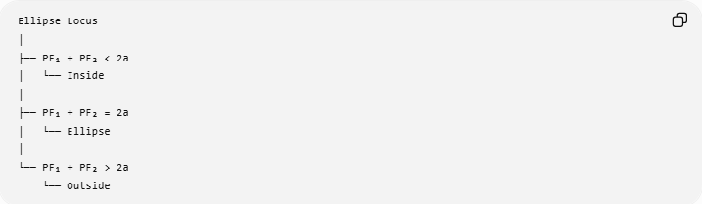
Ellipse Locus
│
├── PF₁ + PF₂ < 2a
│ └── Inside
│
├── PF₁ + PF₂ = 2a
│ └── Ellipse
│
└── PF₁ + PF₂ > 2a
└── Outside
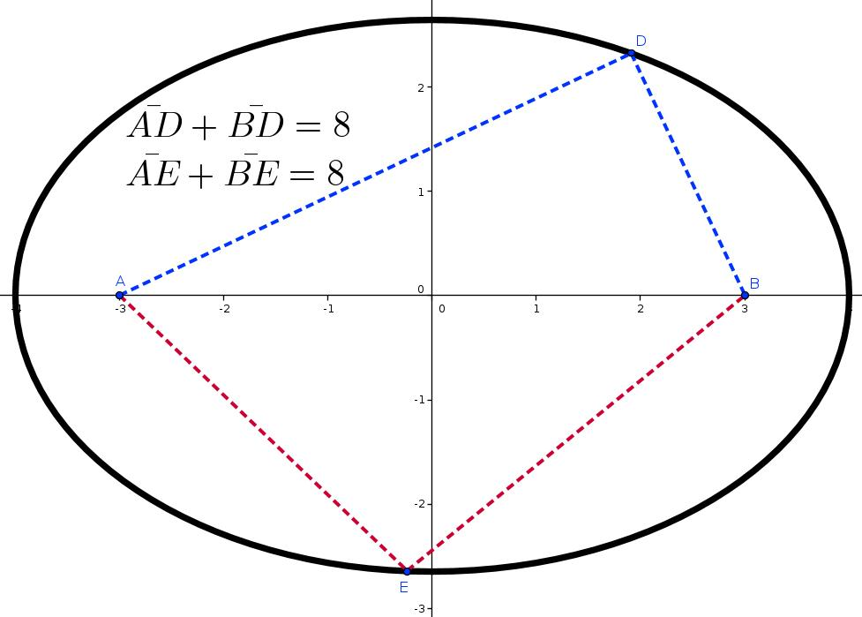
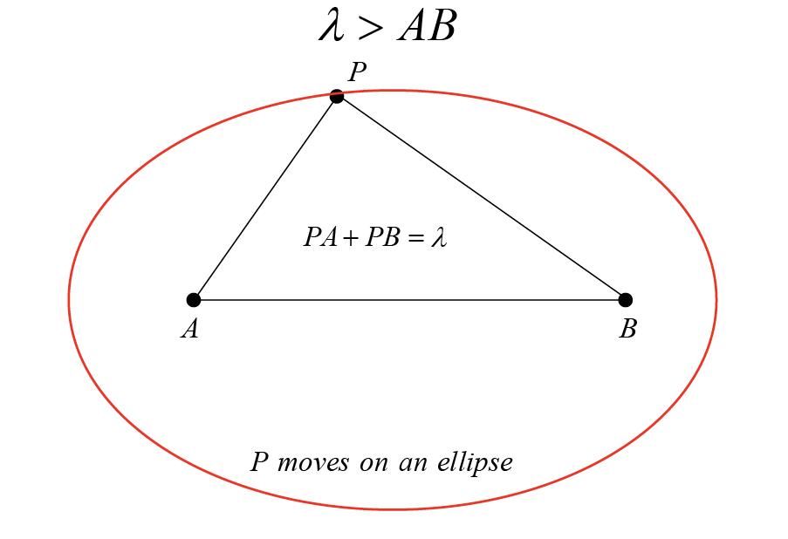
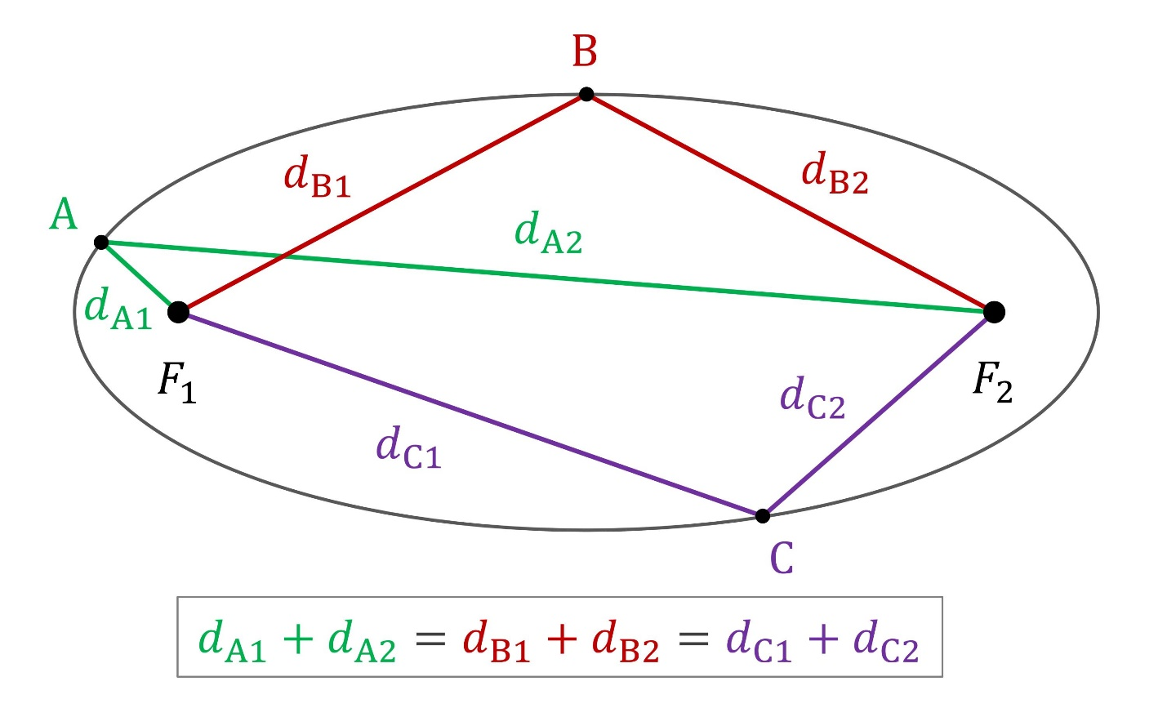

20. Important Boundary Condition
# Source: AI Source: Provided by: [Data Path: Persons Table -> ID Column: 1, Name_En Column: Motasem Essam] -> From: [ChatGPT] on [7/25/2026]
The ellipse is the boundary between the inside and outside regions.
Therefore:
$$\boxed{PF_{1}+PF_{2}=2a}$$
describes only the ellipse itself.
Whereas:
$$PF_{1}+PF_{2}<2a$$
and:
$$PF_{1}+PF_{2}>2a$$
describe regions relative to that boundary.

21. Maximum and Minimum Distance Sum
# Source: AI Source: Provided by: [Data Path: Persons Table -> ID Column: 1, Name_En Column: Motasem Essam] -> From: [ChatGPT] on [7/25/2026]
For two fixed foci separated by $2c$, the constant sum for a nondegenerate ellipse must satisfy:
$$\boxed{2a>2c}.$$
Therefore:
$$\boxed{a>c}.$$
Why?
The minimum possible sum of distances to the two foci is:
$$F_{1}F_{2}=2c.$$
For a genuine ellipse:
$$\boxed{2a>2c}.$$
Since:
$$c^{2}=a^{2}-b^{2},$$
we also have:
$$a>c.$$

22. Special Case — Circle
# Source: AI Source: Provided by: [Data Path: Persons Table -> ID Column: 1, Name_En Column: Motasem Essam] -> From: [ChatGPT] on [7/25/2026]
A circle can be considered a special case of an ellipse.
If:
$$a=b,$$
then:
$$c^{2}=a^{2}-b^{2}=0.$$
Therefore:
$$c=0.$$
The two foci coincide at the center.
The ellipse becomes a circle.
Thus:
$$\boxed{\text{Circle is a special case of an ellipse}}$$
from the conic/locus perspective.
The distance-sum condition becomes:
$$PF_{1}+PF_{2}=2a.$$
Since:
$$F_{1}=F_{2}=O,$$
we obtain:
$$2PO=2a$$
so:
$$\boxed{PO=a}.$$
That is exactly the definition of a circle.

23. Eccentricity
# Source: AI Source: Provided by: [Data Path: Persons Table -> ID Column: 1, Name_En Column: Motasem Essam] -> From: [ChatGPT] on [7/25/2026]
The eccentricity of an ellipse is:
$$\boxed{e=\frac{c}{a}}$$
and for a nondegenerate ellipse:
$$\boxed{0≤e<1}.$$
For a circle:
$$c=0$$
so:
$$\boxed{e=0}.$$
As the foci move farther from the center relative to $a$, the ellipse becomes more elongated.

24. Parabola, Ellipse, and Hyperbola as Loci
# Source: AI Source: Provided by: [Data Path: Persons Table -> ID Column: 1, Name_En Column: Motasem Essam] -> From: [ChatGPT] on [7/25/2026]
These are all conic loci, but their defining distance conditions differ.
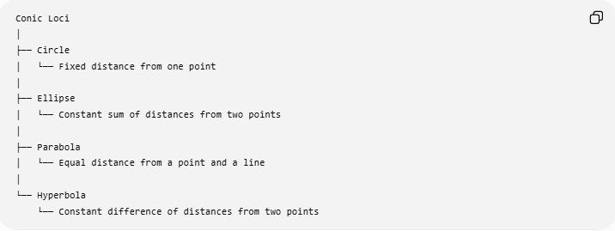
Conic Loci
│
├── Circle
│ └── Fixed distance from one point
│
├── Ellipse
│ └── Constant sum of distances from two points
│
├── Parabola
│ └── Equal distance from a point and a line
│
└── Hyperbola
└── Constant difference of distances from two points
Their fundamental conditions are:
Circle
$$\boxed{OP=r}$$
Ellipse
$$\boxed{PF_{1}+PF_{2}=2a}$$
Parabola
$$\boxed{PF=d\left(P , l\right)}$$
Hyperbola
$$\boxed{∣PF_{1}-PF_{2}∣=2a}$$
This is an important classification of locus definitions.

25. Ellipse vs Parabola
# Source: AI Source: Provided by: [Data Path: Persons Table -> ID Column: 1, Name_En Column: Motasem Essam] -> From: [ChatGPT] on [7/25/2026]
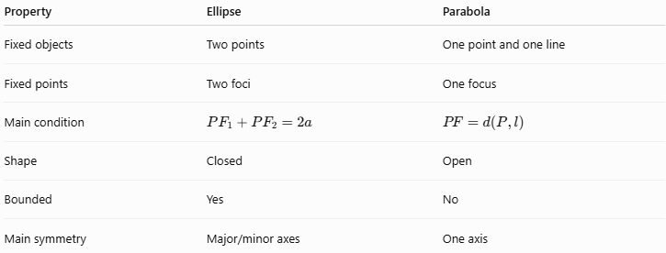
Property | Ellipse | Parabola
Fixed objects | Two points | One point and one line
Fixed points | Two foci | One focus
Main condition | $$PF_{1}+PF_{2}=2a$$ | $$PF=d\left(P , l\right)$$
Shape | Closed | Open
Bounded | Yes | No
Main symmetry | Major/minor axes | One axis
The key difference is:
$$\boxed{\text{Ellipse}=\text{constant sum of two distances}}$$
while:
$$\boxed{\text{Parabola}=\text{equality of point-line distances}}.$$

26. Ellipse vs Hyperbola
# Source: AI Source: Provided by: [Data Path: Persons Table -> ID Column: 1, Name_En Column: Motasem Essam] -> From: [ChatGPT] on [7/25/2026]
The ellipse uses a sum:
$$\boxed{PF_{1}+PF_{2}=2a}.$$
The hyperbola uses a difference:
$$\boxed{∣PF_{1}-PF_{2}∣=2a}.$$
Therefore:
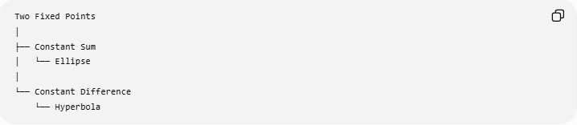
Two Fixed Points
│
├── Constant Sum
│ └── Ellipse
│
└── Constant Difference
└── Hyperbola

27. Important Properties of the Ellipse
# Source: AI Source: Provided by: [Data Path: Persons Table -> ID Column: 1, Name_En Column: Motasem Essam] -> From: [ChatGPT] on [7/25/2026]
For a nondegenerate ellipse:
- It has two foci.
- It is a closed curve.
- It is bounded.
- It has a center.
- It has a major axis.
- It has a minor axis.
- The foci lie on the major axis.
- The foci are symmetric about the center.
- The distance sum is constant:
$$PF_{1}+PF_{2}=2a.$$
- The major-axis length is:
$$2a.$$
- The minor-axis length is:
$$2b.$$
- The focal distance is:
$$2c.$$
- The fundamental relation is:
$$c^{2}=a^{2}-b^{2}.$$
- Its eccentricity satisfies:
$$0≤e<1.$$

28. Classification Summary
# Source: AI Source: Provided by: [Data Path: Persons Table -> ID Column: 1, Name_En Column: Motasem Essam] -> From: [ChatGPT] on [7/25/2026]
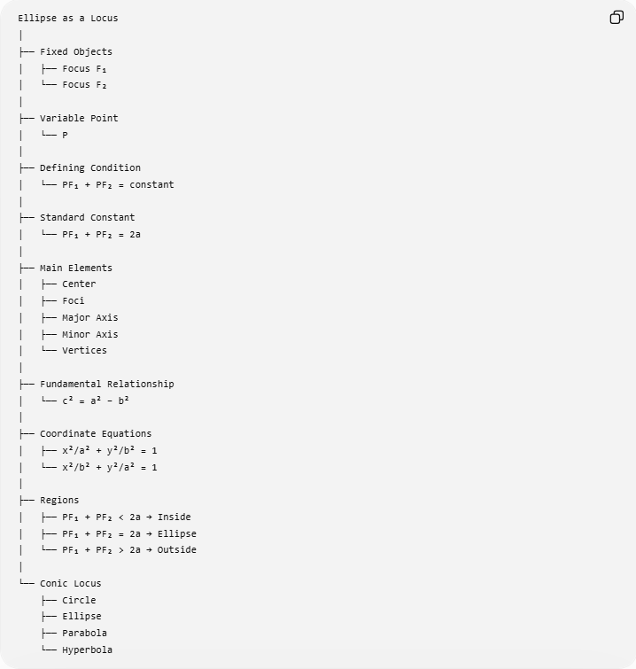
Ellipse as a Locus
│
├── Fixed Objects
│ ├── Focus F₁
│ └── Focus F₂
│
├── Variable Point
│ └── P
│
├── Defining Condition
│ └── PF₁ + PF₂ = constant
│
├── Standard Constant
│ └── PF₁ + PF₂ = 2a
│
├── Main Elements
│ ├── Center
│ ├── Foci
│ ├── Major Axis
│ ├── Minor Axis
│ └── Vertices
│
├── Fundamental Relationship
│ └── c² = a² − b²
│
├── Coordinate Equations
│ ├── x²/a² + y²/b² = 1
│ └── x²/b² + y²/a² = 1
│
├── Regions
│ ├── PF₁ + PF₂ < 2a → Inside
│ ├── PF₁ + PF₂ = 2a → Ellipse
│ └── PF₁ + PF₂ > 2a → Outside
│
└── Conic Locus
├── Circle
├── Ellipse
├── Parabola
└── Hyperbola

29. Key Formulas
# Source: AI Source: Provided by: [Data Path: Persons Table -> ID Column: 1, Name_En Column: Motasem Essam] -> From: [ChatGPT] on [7/25/2026]
Locus definition
$$\boxed{PF_{1}+PF_{2}=2a}$$
Focal distance
$$\boxed{F_{1}F_{2}=2c}$$
Fundamental relationship
$$\boxed{c^{2}=a^{2}-b^{2}}$$
Horizontal ellipse
$$\boxed{\frac{x^{2}}{a^{2}}+\frac{y^{2}}{b^{2}}=1}$$
Vertical ellipse
$$\boxed{\frac{x^{2}}{b^{2}}+\frac{y^{2}}{a^{2}}=1}$$
Eccentricity
$$\boxed{e=\frac{c}{a}}$$
Inside
$$\boxed{PF_{1}+PF_{2}<2a}$$
On ellipse
$$\boxed{PF_{1}+PF_{2}=2a}$$
Outside
$$\boxed{PF_{1}+PF_{2}>2a}$$

Conclusion
# Source: AI Source: Provided by: [Data Path: Persons Table -> ID Column: 1, Name_En Column: Motasem Essam] -> From: [ChatGPT] on [7/25/2026]
The ellipse as a locus is the set of all points $P$for which the sum of the distances to two fixed points $F_{1}$and $F_{2}$remains constant:
$$\boxed{PF_{1}+PF_{2}=2a}.$$
The two fixed points are the foci, and $2a$is the length of the major axis. This distance-sum definition makes the ellipse one of the fundamental conic loci, alongside the circle, parabola, and hyperbola.
The central principle is:
$$\boxed{\text{Constant Sum of Distances from Two Fixed Points}⟶\text{Ellipse}}$$

